1.Write a c program to check the given number is odd or even?

**PROGRAM:**

#include<stdio.h>

int main()

{

int num;

printf("enter a number:");

scanf("%d",&num);

if(num%2==0)

{

printf("\n %d is a even number:",num);

}

else

{

printf("\n %d is a odd number:",num);

}

return 0;

}

**OUTPUT:**

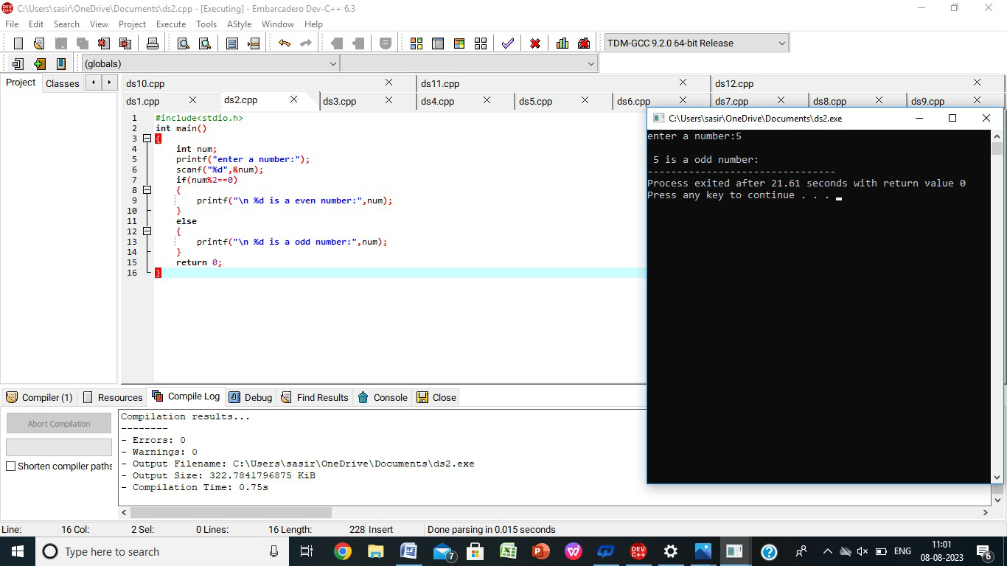

2.write a c program for sum of first n numbers using any loop?

**PROGRAM:**

#include<stdio.h>

int main()

{

int num,sum=0,i;

printf("enter the number:");

scanf("%d",&num);

for(i=0;i<=num;i++)

{

sum=sum+i;

}

printf("\n %d is sum of first n natural numbers",sum);

return 0;

}

**OUTPUT:**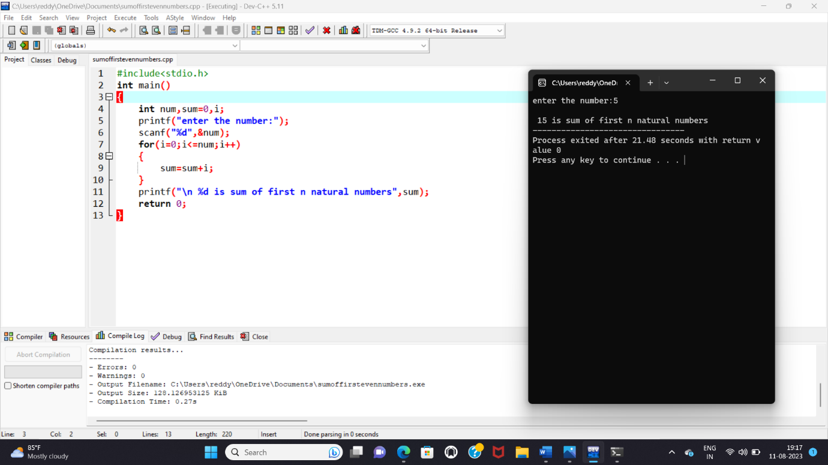

3.write a c program of sum of even numbers using any loop?

**PROGRAM:**

#include<stdio.h>

int main()

{

int num,sum=0,i=0;

printf("enter the number:");

scanf("%d",&num);

while(i<=num)

{

if(i%2==0)

{

sum=sum+i;

}

i++;

}

printf("\n %d is sum of first n natural numbers",sum);

return 0;

}

**OUTPUT:**

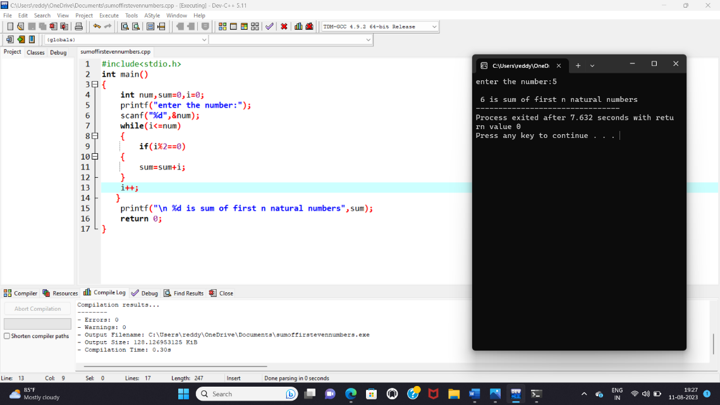

4.write a c program to reverse a number?

**PROGRAM:**

#include<stdio.h>

int main()

{

int num,q,result=0,rem;

printf("enter a number:");

scanf("%d",&num);

q=num;

while(q!=0)

{

rem=q%10;

result=result*10+rem;

q=q/10;

}

printf("\n %d reverse number of %d",result,num);

return 0;

}

**OUTPUT:**

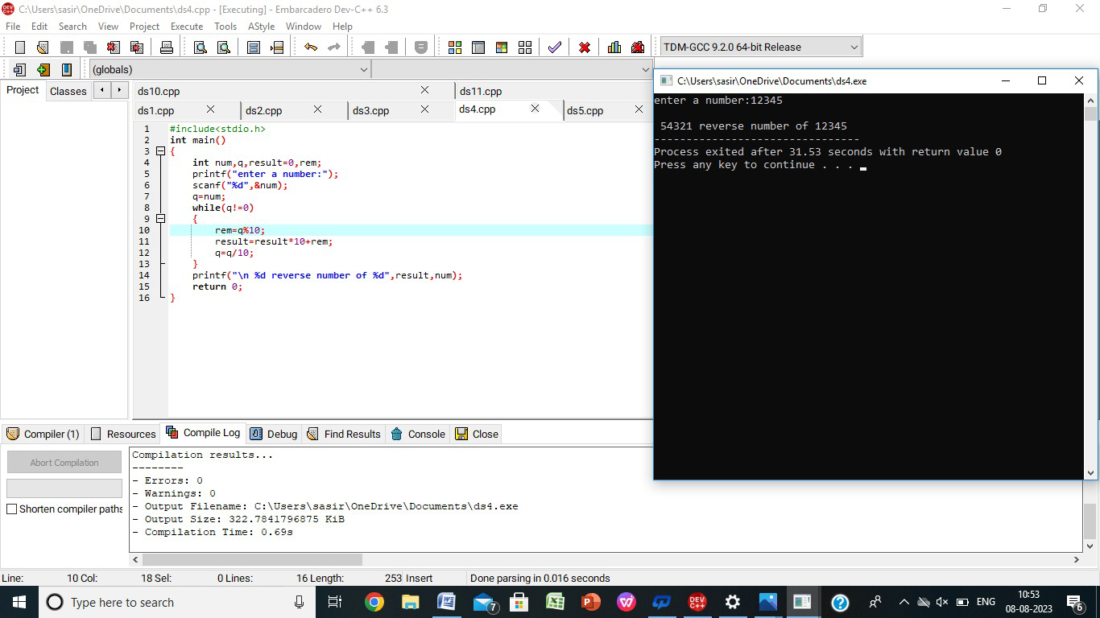

5.write a c program to check whether a number is palindrome or not?

**PROGRAM:**

#include<stdio.h>

int main()

{

int num,q,result=0,rem;

printf("enter a number:");

scanf("%d",&num);

q=num;

while(q!=0)

{

rem=q%10;

result=result*10+rem;

q=q/10;

}

if(result==num)

printf("\n it is a palindrome");

else

printf("\n it is not a palindrome:");

return 0;

}

**OUTPUT:**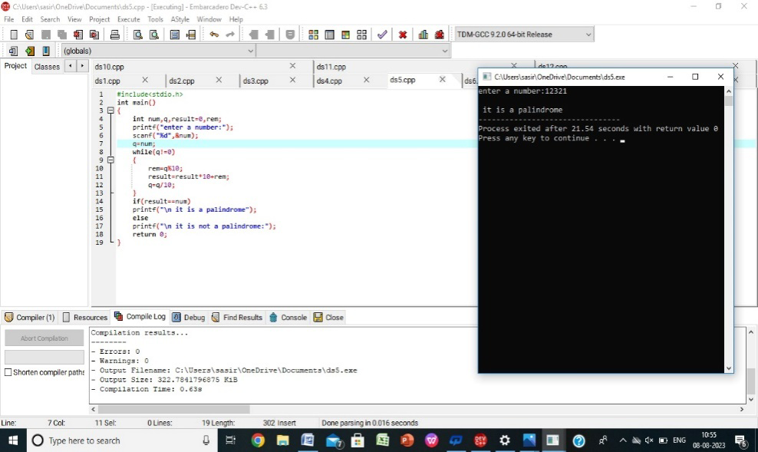

6.write a c program to check whether it is a Armstrong or not?

**PROGRAM:**

#include<stdio.h>

int main()

{

int q,num,count=0,result=0,mul=1,cnt,rem;

printf("enter a number:");

scanf("%d",&num);

q=num;

while(q!=0)

{

q=q/10;

count++;

}

cnt=count;

q=num;

while(q!=0)

{

rem=q%10;

while(cnt!=0)

{

mul=mul*rem;

cnt--;

}

result=result+mul;

cnt=count;

q=q/10;

mul=1;

}

if(result==num)

{

printf("\n %d is a armstrong number",num);

}

else

{

printf("\n it is not a armstrong number:");

}

return 0;

}

**OUTPUT:**

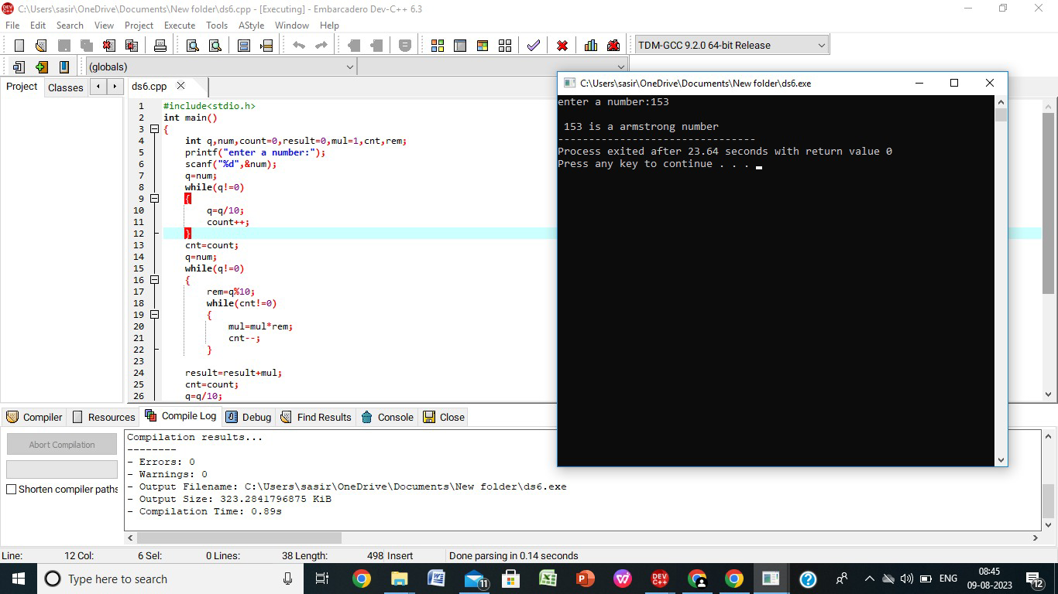

7.write a c program to find factorial of given number without recursion?

**PROGRAM:**

#include<stdio.h>

int main()

{

int n,i;

unsigned long long fact=1;

printf("enetr a number:");

scanf("%d",&n);

if(n<0)

{

printf("\n factorial of negative number doesnot exist");

}

else

{

for(i=1;i<=n;i++)

{

fact=fact*i;

}

printf("\n %d is factorial of %d",fact,n);

}

return 0;

}

**OUTPUT:**

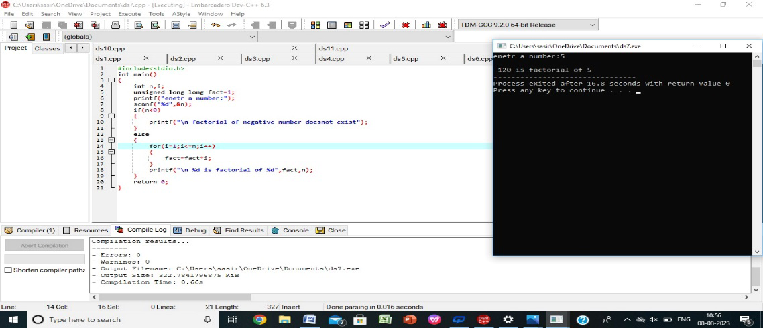

8.wtite a c program to find factorial with recursion?

**PROGRAM:**

#include<stdio.h>

long factorial(int n)

{

if(n==0)

return 1;

else

return(n*factorial(n-1));

}

int main()

{

int num;

long fact;

printf("enter a number:");

scanf("%d",&num);

fact=factorial(num);

printf("\n %d factorial is %d",num,fact);

return 0;

}

**OUTPUT:**

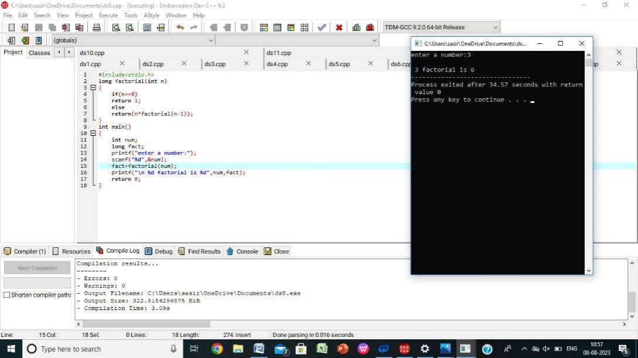

9.write a c program to generate fibanocci series without recursion?

**PROGRAM:**#include<stdio.h>

int main()

{

int n,a,b,c,i;

printf("enter the number of terms:");

scanf("%d",&n);

a=0;

b=1;

while(i<n)

{

printf("\n%d",a);

c=a+b;

a=b;

b=c;

i++;

}

return 0;

}

**OUTPUT:**

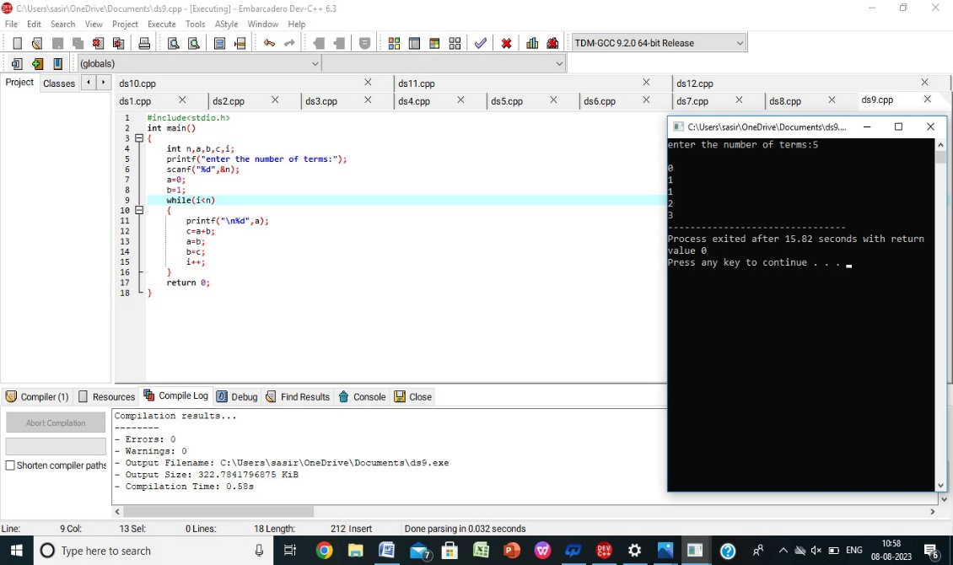

10.write a c program to generate fibanocci series with recursion?

**PROGRAM:**

#include<stdio.h>

int fibanocci(int n)

{

static int a=0,b=1,c;

if(n>0)

{

printf("\n%d",a);

c=a+b;

a=b;

b=c;

fibanocci(n-1);

}

}

int main()

{

int n;

printf("enter the number of terms:");

scanf("%d",&n);

fibanocci(n);

return 0;

}

**OUTPUT:**

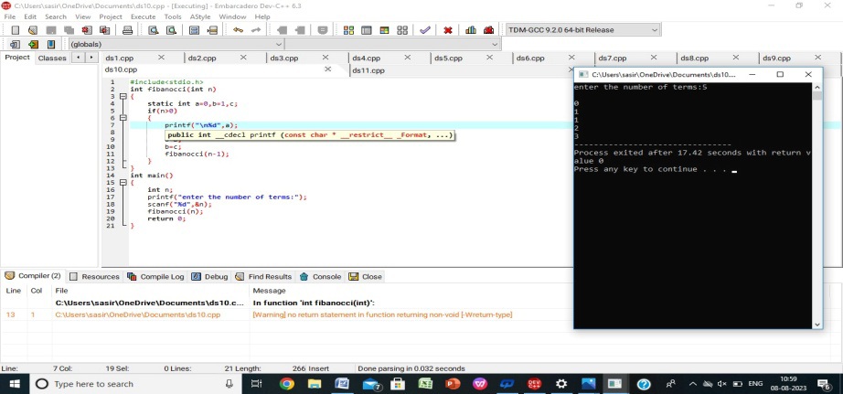

11.write a c program to search particular element in array using linear search?

**PROGRAM:**

#include<stdio.h>

int main()

{

int n,a[100],i,num;

printf("enter the size of array:");

scanf("%d",&n);

printf("enter the elements in array:");

for(i=0;i<n;i++)

{

scanf("%d",&a[i]);

}

printf("\n enter a number to search using linear search");

scanf("%d",&num);

for(i=0;i<n;i++)

{

if(a[i]==num)

{

printf("\n number %d found at index %d",num,i);

break;

}

}

if(i==n)

{

printf("\n number %d is not present");

}

return 0;

}

**OUTPUT:**

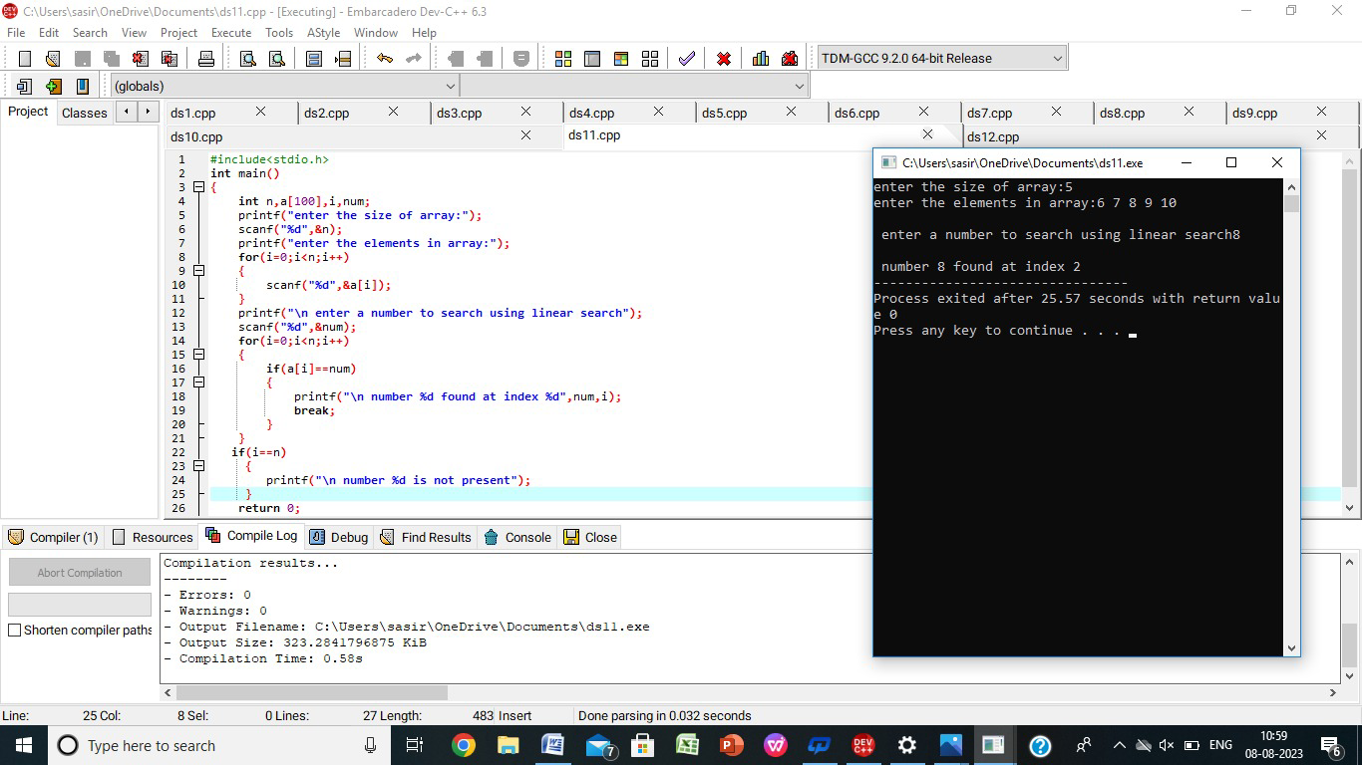

12.write a c program to search particular element in array using binary search?

**PROGRAM:**

#include<stdio.h>

int main()

{

int i,low,high,mid,n,key,a[100];

printf("enter the size of array");

scanf("%d",&n);

printf("\n enter the elements:");

for(i=0;i<n;i++)

{

scanf("%d",&a[i]);

}

printf("\n enter the value to find:");

scanf("%d",&key);

low=0;

high=n-1;

mid=(low+high)/2;

while(low<=high)

{

if(a[mid]<key)

low=mid+1;

else if(a[mid==key])

{

printf("\n %d found at loaction %d",key,mid);

break;

}

else

high=mid-1;

mid=(low+high)/2;

}

if(low>high)

{

printf("\n not found %d",key);

}

return 0;

}

**OUTPUT:**

